Copyright for test papers and marking guides remains with *West Australian Test Papers.*

Test papers may only be reproduced within the purchasing school according to the advertised Conditions of Sale.

Test papers should be withdrawn after use and stored securely in the school until Friday June 12th 2020.



**MATHEMATICS**

**SPECIALIST**

**UNIT 3**

**Semester One**

**2020**

**SOLUTIONS**

***Calculator−free Solutions***

1. (a) ✓

(b) ✓✓

✓✓

(c) No, because does not exist for . ✓✓ [7]

2. (a) and given, then:

✓✓

✓✓

(b) ✓

answers must be parallel to ✓

✓

✓✓ [9]

3. (a) (i) ✓✓✓

(ii) ✓

✓

✓

(b) (i) is a root of

✓

✓

is a root of as per the factor theorem.

(ii) Since the coefficients of are real, then is

also as root. ✓

✓

Solutions are ✓✓ [12]

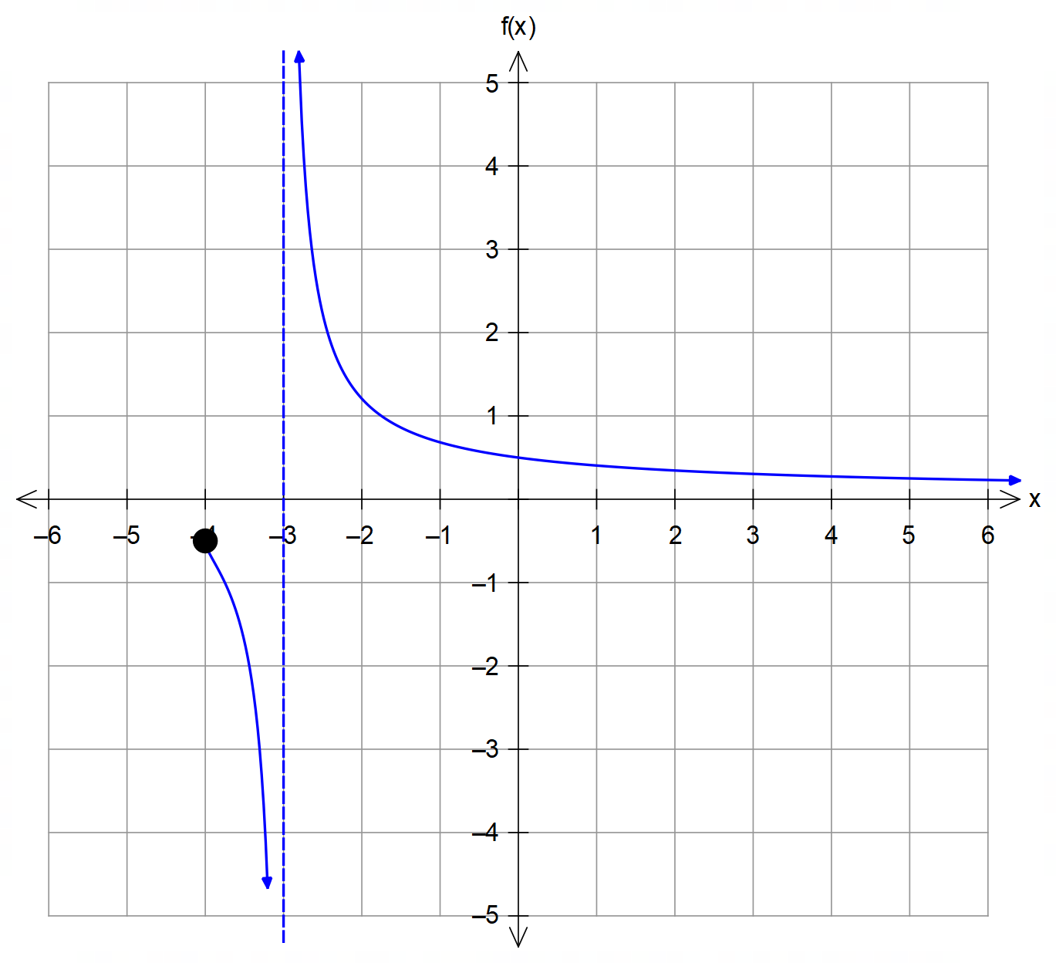4. (a)

✓ asymptote y = 0

and a pole x=-3

✓✓ behaviour on either side of the pole.

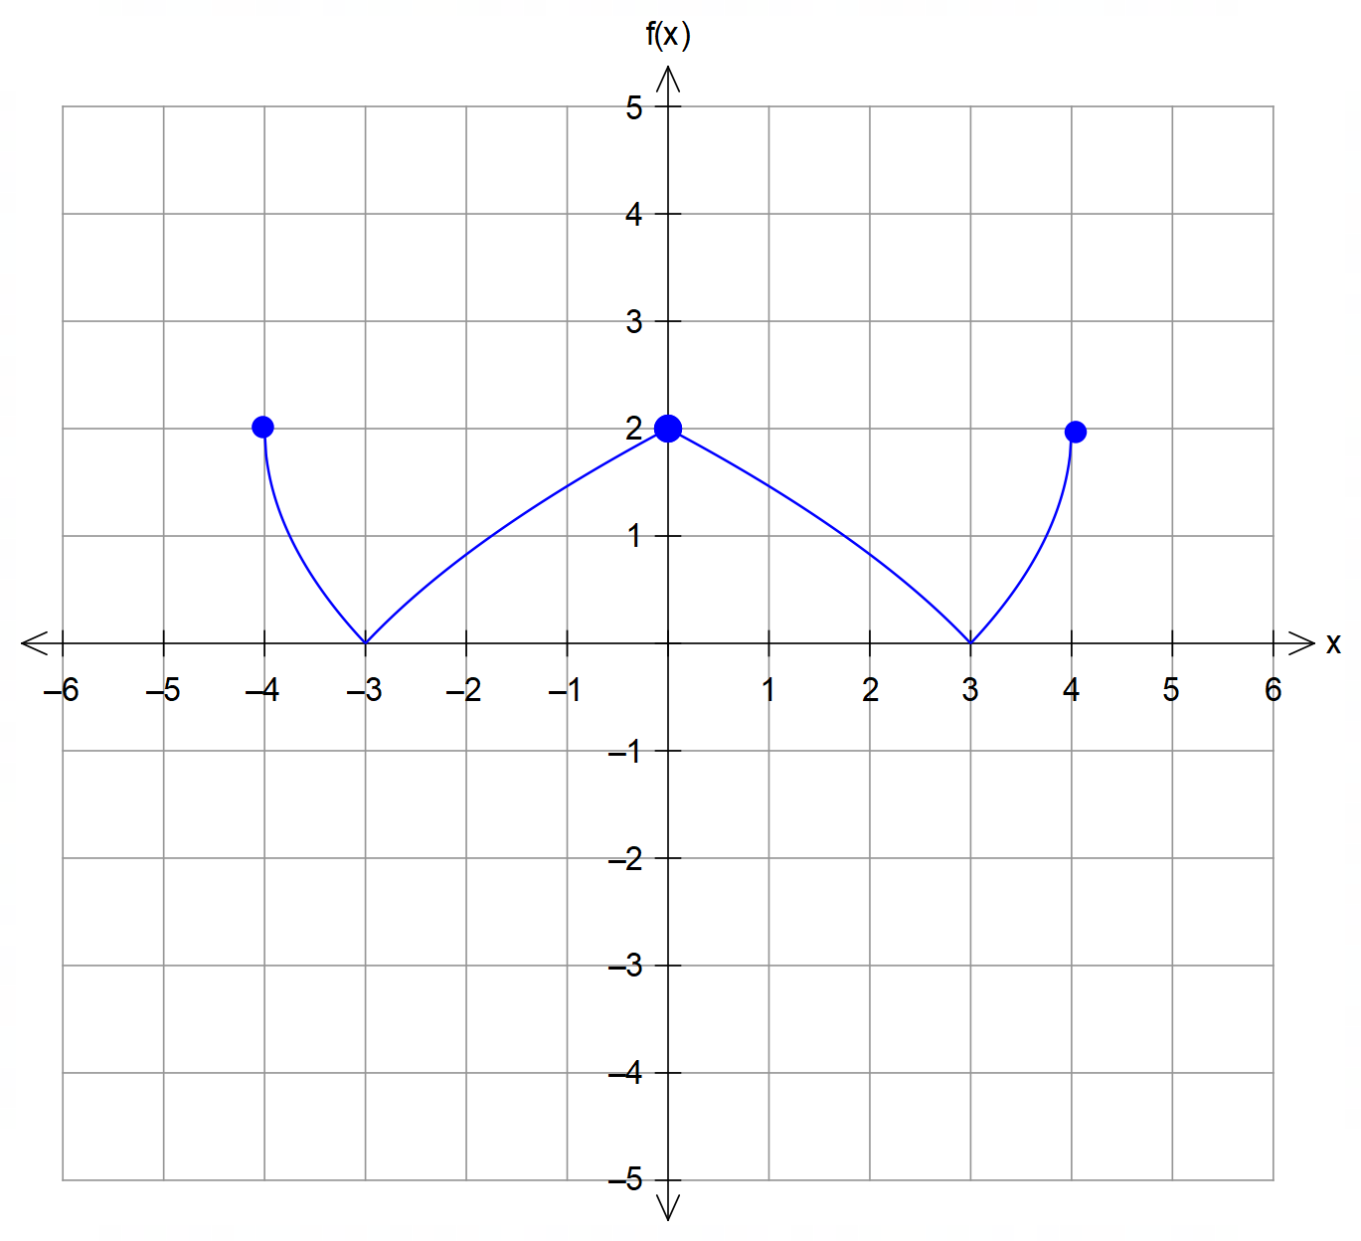

(b)

✓ roots

y-intercept y=2

✓✓ symmetry and

curvature

(c) ✓

✓

✓ [9]

5. (a) ✓✓✓

(any algebraic method or matrix method accepted)

5. (b) The normal vectors to the three planes are and

Solutions do not exist for ✓

which is when the three planes are non-parallel but do not

intersect at a single point in space. ✓

Solutions exist for ✓ [6]

6. (a) ✓

(b) ✓✓

(c) centre = midpoint ✓

radius ✓

✓ [6]

7. Solutions must satisfy:

✓

✓

from symmetry, the roots must be equally spaced at intervals

of therefore ✓✓ [4]

(it must be an odd multiple of 3)

(any explanation based on symmetry is acceptable)

***Calculator−Assumed Solutions***

8. Discontinuities at ✓✓

Oblique asymptote is given by

✓✓

using the point given:

✓ [5]

9. (a) and ✓✓

CAS ✓

(b) Let ✓

(Other solutions exist)

(c) (i) ✓✓

as required

(ii) Normal equation of the plane needed:

✓

✓

✓

(d) Since L in (c)(ii) passes through the origin, then is

the position vector of the point of shortest distance from O.

✓ [10]

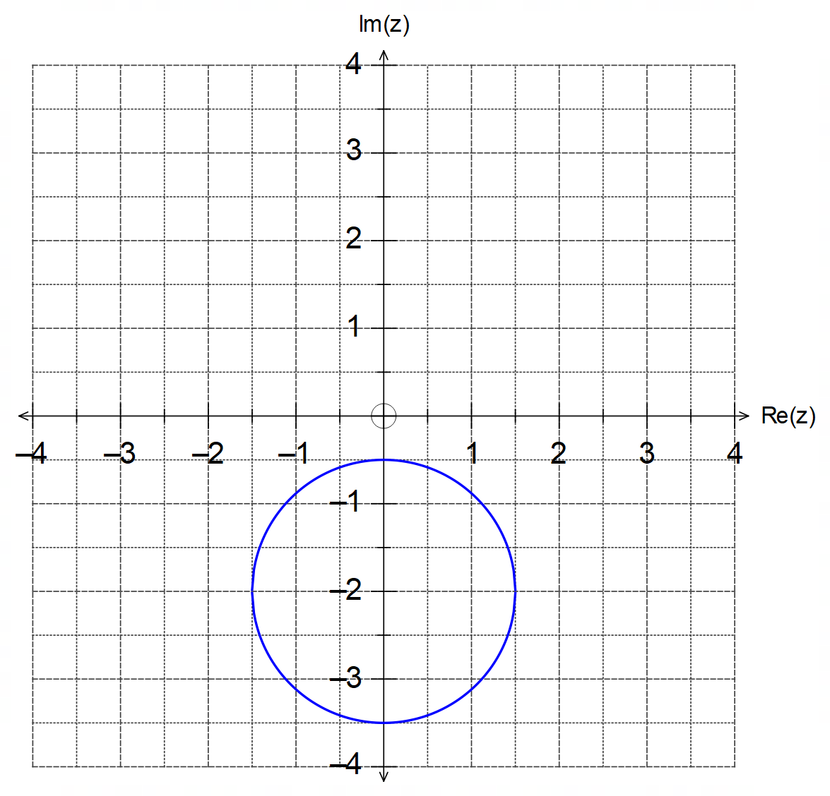10. (a) (i)

✓ circle

✓centred at (0,-2)

✓radius of 1.5 units

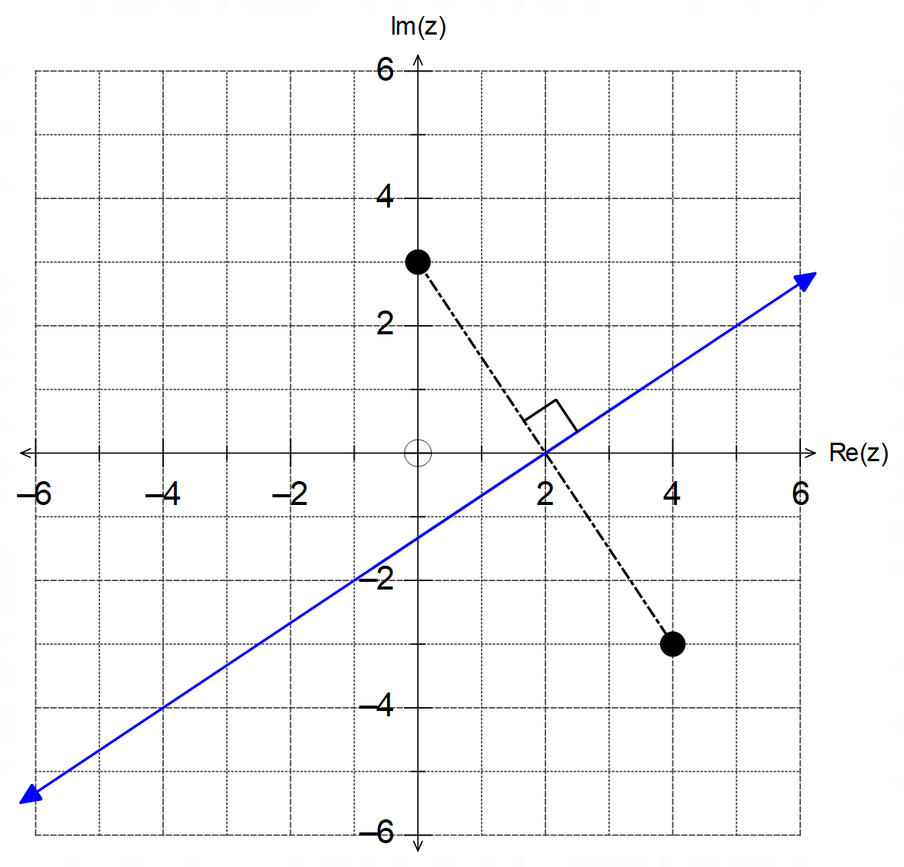

(ii)

✓ line

or passes through

the points (2,0)

and (-1, -2)

✓✓ perpendicular

bisector between

points given

(b) is a translation of 1 unit down. ✓

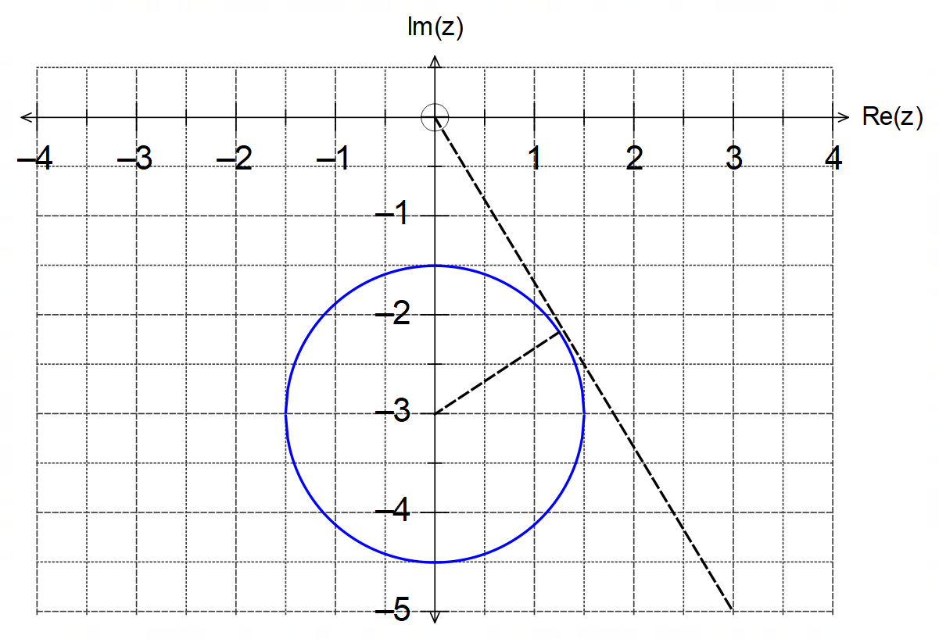

From diagram: ✓

and occurs in 4th quadrant:

✓✓ [10]

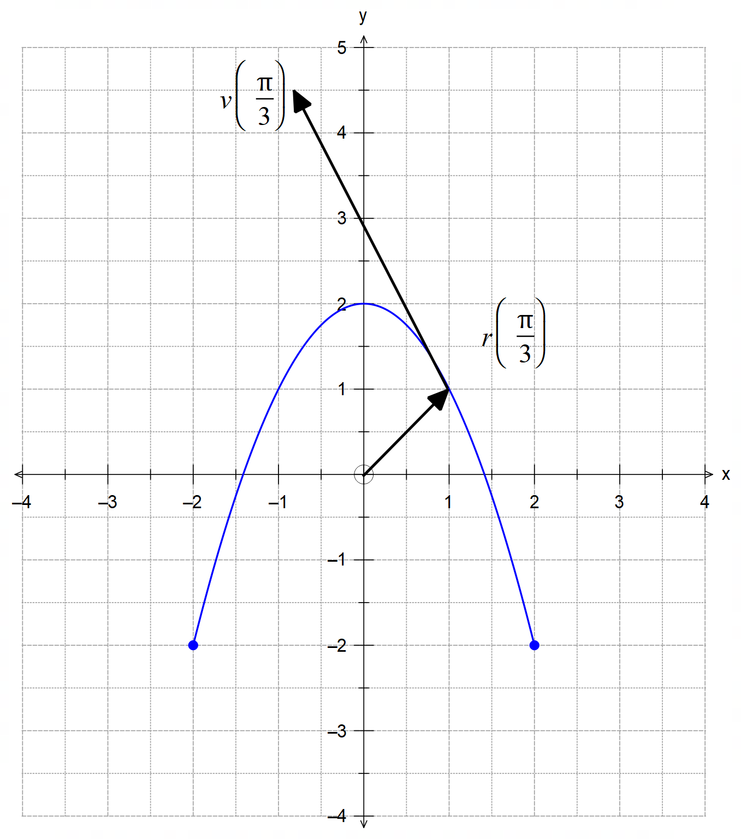11. (a)

(a)

✓✓ parabola

✓ restricted domain

(c)

✓ position vector

✓ velocity vector

from (1,1)

(b) ✓

(c) ✓

✓

✓✓

(d)

✓

✓

(e) ✓

✓

as required.

(f) ✓

✓

with ✓ [17]

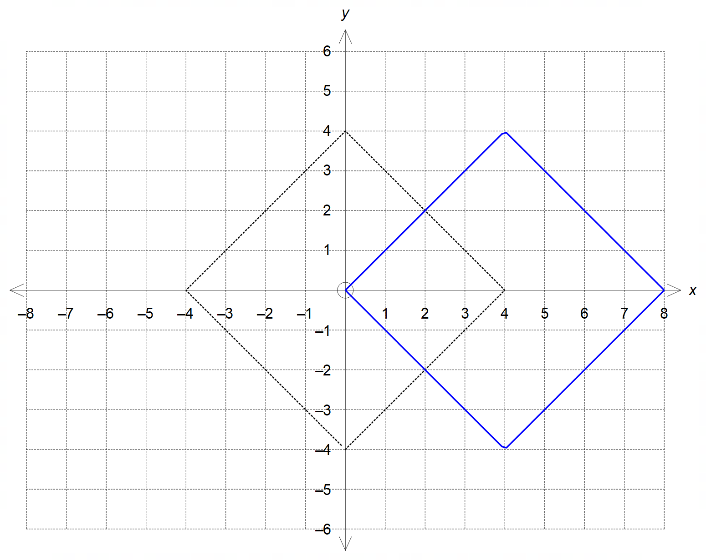12. (a)

✓shape/accuracy

✓ location

(b) is a circle and can intersect the square four times at

either its vertices, or use its sides as tangents.

✓✓

(c) ✓✓ [6]

13. (a) Solution given is ✓

✓✓

Other solutions can be graphed and then listed:

✓✓

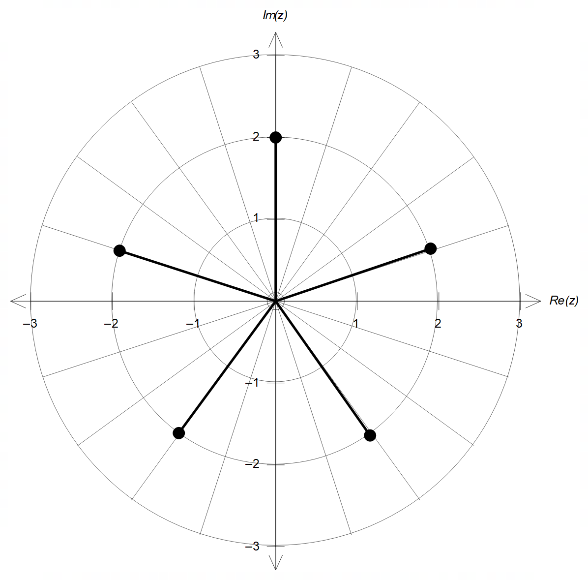

✓ magnitude of 2

✓ apart (4 div)

13. (b) (i)

(ii)

(iii)

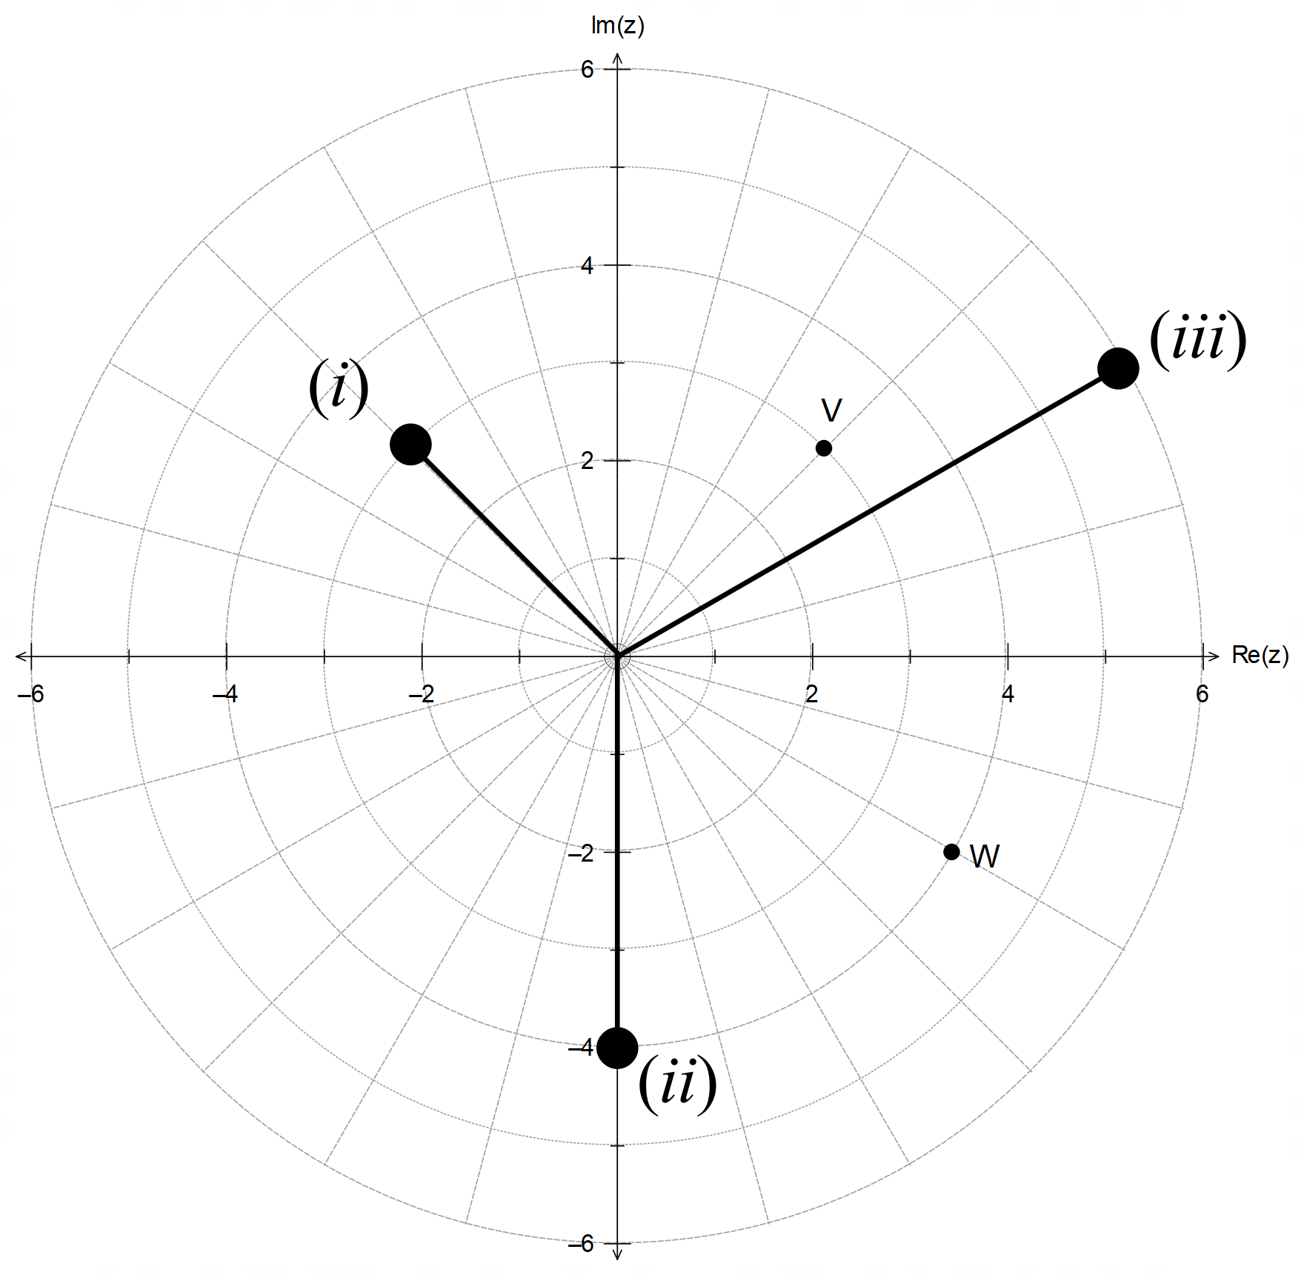

✓ magnitude

✓ argument

(each)

[13]

14. (a) Location of collision:

✓

✓✓

✓

(b) Resetting timer/position for particle A;

✓✓

14. (c) from (b)

✓

and

✓

CAS ✓

✓

✓ [11]

15. (a) ✓

✓✓

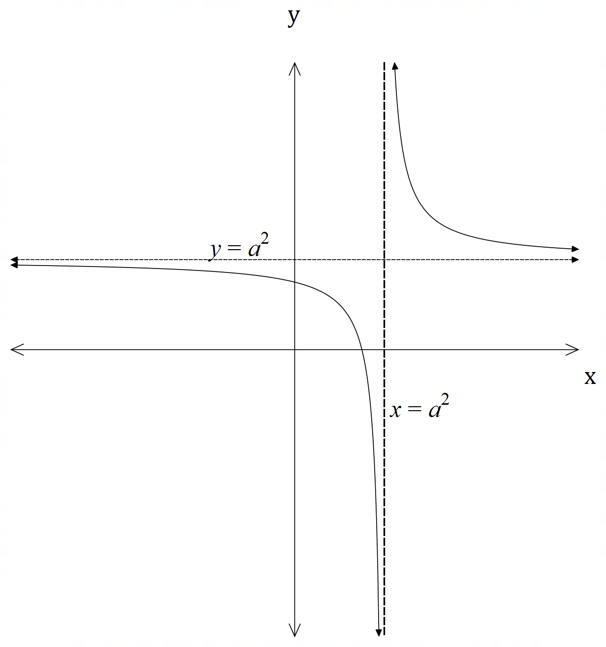 (b)

✓ asymptote

✓ pole

✓ positive rectangular

hyperbola

(c) (i) ✓✓

(ii) is an involution and hence it is its own inverse.

The graphs of and are symmetrical over the line .

They have the same set for both its domain and range: .

They have the same asymptote .

They have the same pole ✓✓✓✓ [12]

(any four of these)

16. (a) from De Moivre’s theorem ✓

CAS ✓

✓

✓

(b) Let

from (a) ✓

✓

✓ [7]

17. ✓

✓

and ✓

✓

✓

✓ [6]